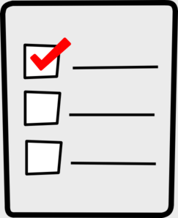
Weekly Checklist
Week of: May 4th

Required Assignments | Required Assignments
Math:  - Do pages 709-714  DO NOT COMPLETE #9, 10A, 10B, 14, 18, 20, and 22  - Video for review pages  - BOOM cards for Chapter 12.  They are GRADED but you can do as many times as you wish. I will take the AVERAGE of you attempts.  Science:  - Video for metamorphosis and questions.  OR  - Do a science experiment and upload it to FlipGrid explaining the science behind it. (Directions on website) | Reading:  - Good Morning Sunshine  - Comprehension Cards  Tales of a Fourth Grade Nothing  - Watch Intro video  - Read or listen to chapters 1-3  - Watch summary video  - Take quiz on forms for  chapters 1-3  Social Studies:  - Southwest video  - Questions about the video

